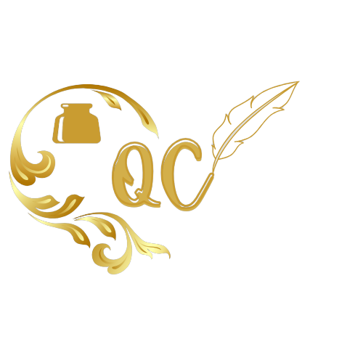

**Quick Calligraphy**

|  |  |  |
| --- | --- | --- |
| **Supervisor.** | **Miss Anum** | |
| **Batch.** | **2306G1** | |
| **Group.** | **A** | |
| **Serial No.** | **Enrollment Number** | **Student Name** |
| 1. | Student1479561 | Nauman Rashid |
| 2. | Student1475155 | M. Arsalan |
| 3. | Student1474867 | Abdul Moiz |
| 4. | Student1476402 | Abid Aslam |

**Acknowledgment**

I would like to acknowledge and give my warmest thanks to our teacher Ms. Anum Hussain who made this work possible. His/her guidance and advice carried us through all the stages of this project.

I would also like to give special thanks to e-Project Team at Aptech for giving us the opportunity in the form of this project that has challenged our skill set which has helped us understand more about our courses this semester and discover new horizon in Web Development.

Finally, I would like to thank God, for letting me through all the difficulties. You are the one who has given us success in our project.

**Synopsis**

Calligraphy, the art of beautiful handwriting. The term may derive from the Greek words for “beauty” (kallos) and “to write” (graphein). It implies a sure knowledge of the correct form of letters—i.e., the conventional signs by which language can be communicated—and the skill to make them with such ordering of the various parts and harmony of proportions that the experienced, knowledgeable eye will recognize such composition as a work of art. But with the increasing in technological luxuries the art is slowing fading. People of modern world just don’t now a days what is the important of a beautiful handwritten document.

With the help of our website, we want to bring the attention of people at this art. We want people to know what different language calligraphy looks like. For our project we have chosen 3 Language (Indic, Greek & Arabic) with rich background under the spot light. We have attached many short videos where you can learn this art & we also provide online classes to people who want master this skill. We also have created a online store where people can buy our hand written calligraphy for any purpose they want, we have provided information on our website on how we can sell this art presented on a Picture Frame or any Canvas they like.

**Descriptive Analysis & Design:**

For this project we needed a lot of research work on the languages that were being showcased on our website. This first challenge was to study the history of these languages, to gain a complete background on them. Each language has its own origin & with that it also has its own culture that needed to highlighted otherwise the website would be just a bland mix of different calligraphy styles.

That was our second challenge to show case all these languages in a way that they don’t get mix-up and still maintain their culture integrity. We needed a design that was suitable for all languages with colors that speaks for each one them. With a lot searching online we decide that a mix of black, white & green would be a good fit.

After all of that was done, we need a structure of website. So, we started working on that, we decided to go with the standard structure (Home, Gallery, Products, Contact Us & About Us). Since trying anything new would be a lot of time consuming a we had already spent most of our time on research.

**e-Project Requirements:**

* The home page must describe the keywords or highlight the calligraphy designs with all navigation links defined.
* The site should provide the brief information about calligraphy as from where it originated etc.
* There should be a well-designed menu with necessary sub menu options.
* There should be various categories (forms and styles) like easy for kids, complex for elders and so on.
* There should also be categories of designs as Arabic, Indic, Greek etc. (more categories can be added)
* Proper description of the letters and fonts must be added in the website.
* Contact us page: contact us details with location should be displayed using Geolocation API (e.g., Google Maps).
* About Us.
* Feedback form.
* Gallery section should be added.
* Color combination must be uniform throughout the project.
* Navigation must be smooth.

**Site Map:**

**Wireframes:**

**Navbar:**

**About :**

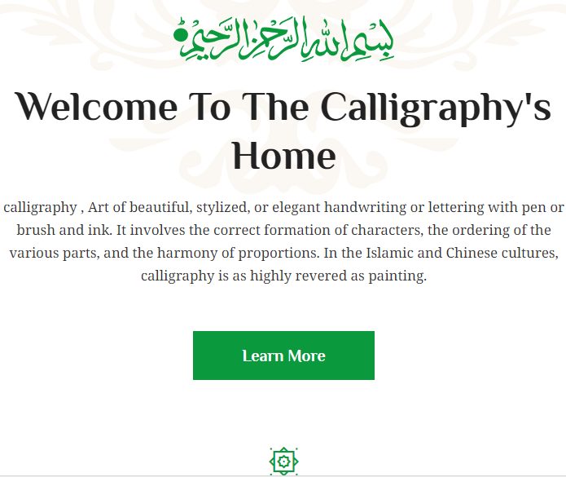

Calligraphy: Art of beautiful, stylized, or elegant handwriting or lettering with pen or brush and ink. It involves the correct formation of characters, the ordering of the various parts, and the harmony of proportions. In the Islamic and Chinese cultures, calligraphy is as highly revered as painting.

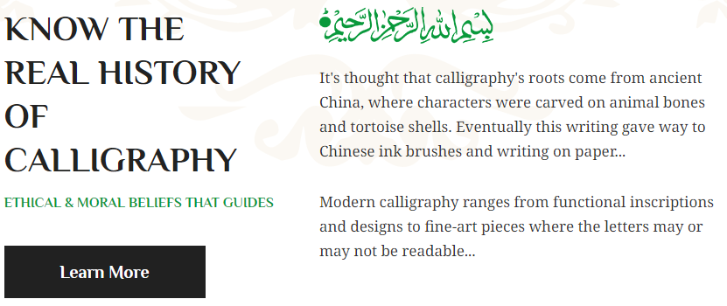

**Services:**

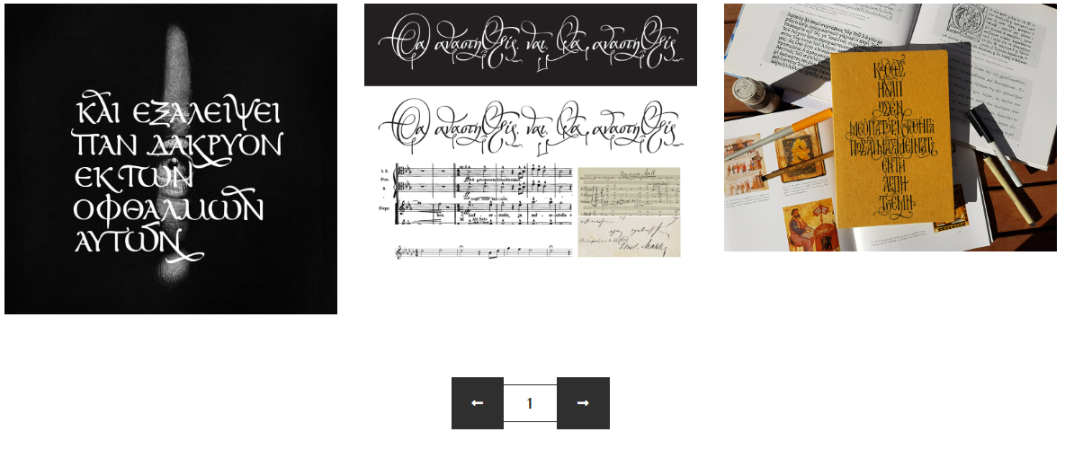Gallery:

This area of our website was also made with the help of Bootstrap Cards. I this section we have tried to show the client what calligraphy styles are we working or have previously worked on.

Products:

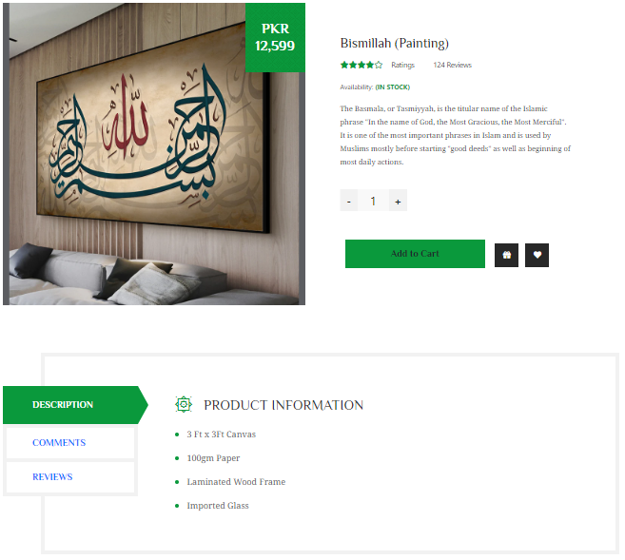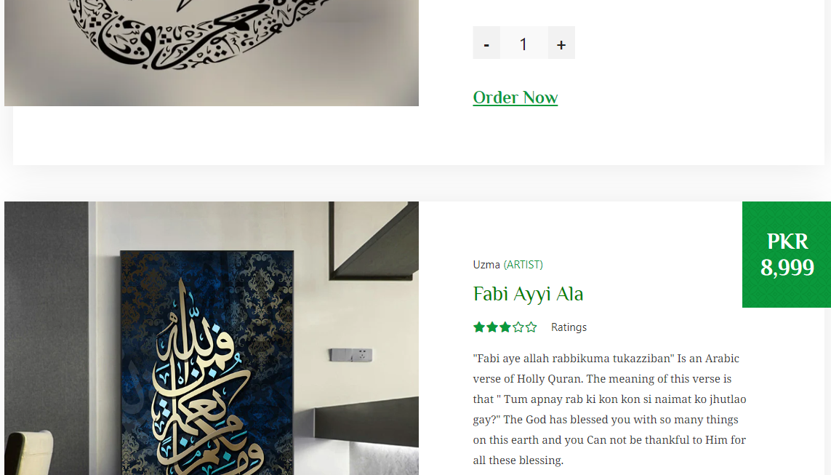

We have given a proper description section when customer click on “Order Now”. We have also added comment section where he/she can see our previous customers responses. And we have made a review section in case anyone wants leave any further comments. We have also made checkout system with the help of Modal.

In this section, we have made products cards with help of Bootstrap.

This is where customers can buy our Custom Calligraphy Frames in all Languages.

[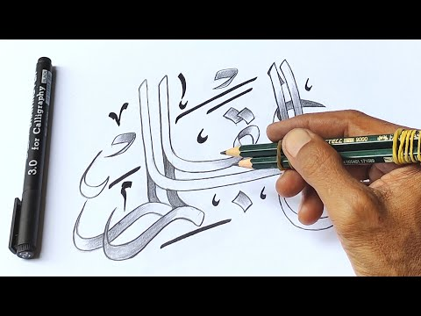](https://www.youtube.com/embed/kLDqK1HWb2E?feature=oembed)Video Links:

[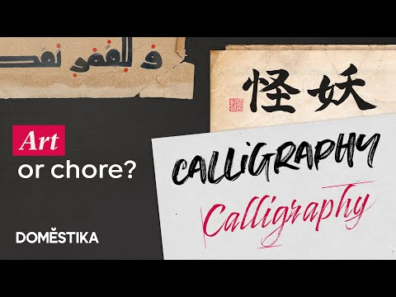](https://www.youtube.com/embed/K6g3YOy7FC0?feature=oembed)We have also added a Video links on the website that explain the beautiful art of calligraphy in 3 different languages.

We have also added Video links, and tried to explain to our visitors the history of Calligraphy & its importance.

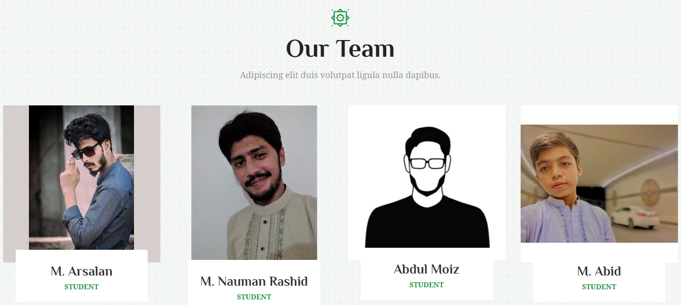Meet Our Team:

In the About Us page we have also made a Meet our Team section, where visitors can meet and get to know about the people whose has created this project.

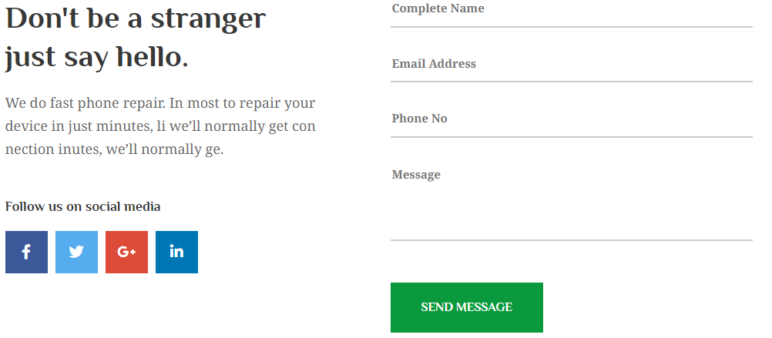Contact Us:

On the Contact Us page, we have made two sections. First section is where we have given all of our information and location. And the Second section contain a Contact Us form. This was also made with help of Bootstrap. In 2 Columns, 1 contains our links to social media sites & the other contains a form that let user get in touch with directly if he/she has a query or concern.

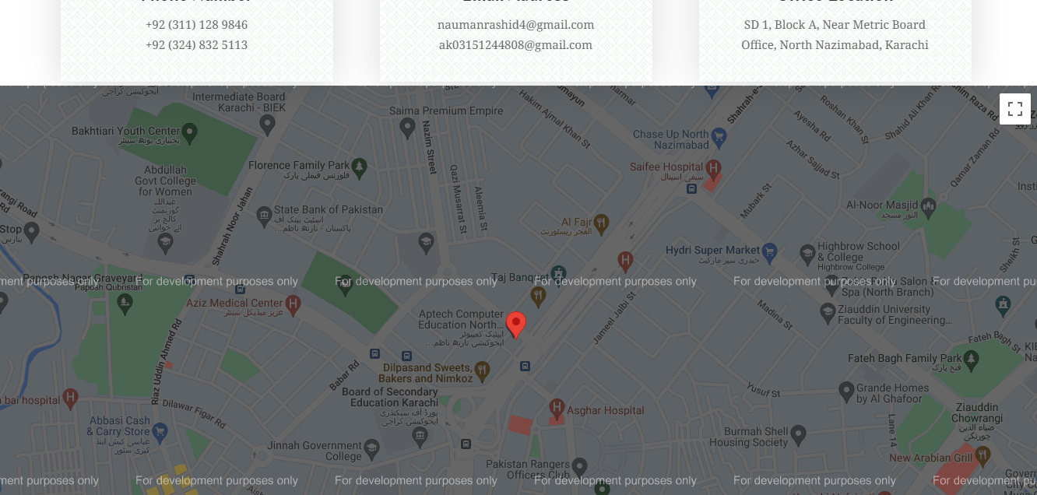Geo-location:

We have also added location of our site. This was done by the help of geo-location Api.

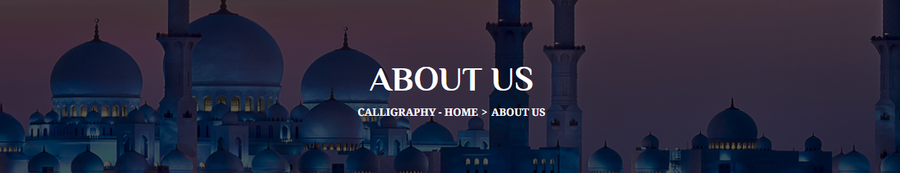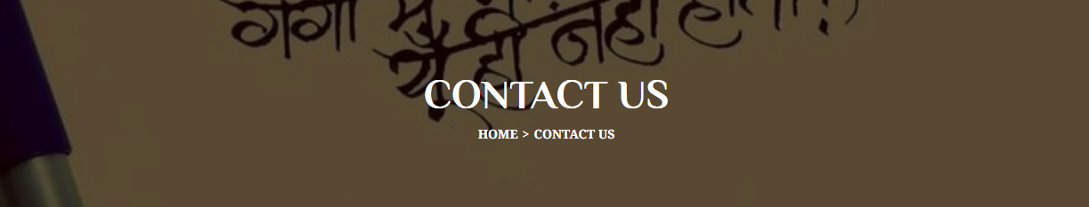Banners:

We have also made banners on our websites and applied breadcrumbs on it with the help of Bootstrap to help user navigate.

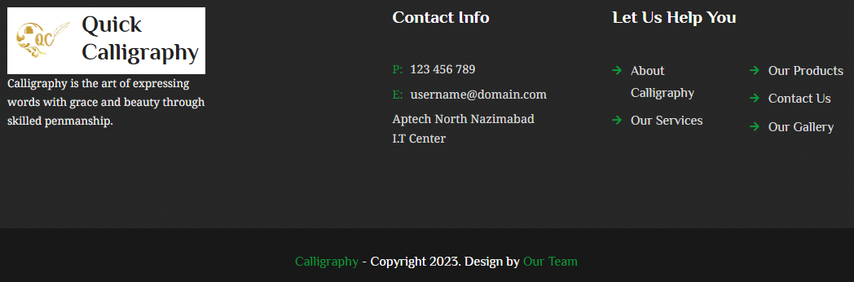Footer:

At the end of each of our page we have made a footer that has a few links of contact & email address.

**Task Sheet Review:**

|  |  |  |  |  |  |  |
| --- | --- | --- | --- | --- | --- | --- |
| Project Ref. No.: eP/Advertisement Portal Management System/01 | | Project  Title | Date of Preparation of Activity Plan | | | |
| No | Task | Quick Calligraphy | Actual | Actual | Team-mate | Status |
| Start Date | Days | Names |
| 1 | Research Work | 24/Sep/23 | 8 | Nauman, Arsalan, Moiz | Complete |
| 2 | Build Homepage with styling. | 2/Oct/23 | 2 | Arsalan | Complete |
| 3 | Build Gallery and Contact Us pages | 04/Oct/22 | 2 | Nauman | Complete |
| 8 | Build Responsive Header & Footers | 06/Oct/23 | 3 | Arsalan | Complete |
| 4 | Build Product Cards with checkout page. | 06/Oct/23 | 5 | Nauman | Complete |
| 5 | Build Service Page (Kids & Elders) | 06/Oct/23 | 5 | Moiz | Complete |
| 6 | Build About Us page | 06/Oct/23 | 3 | Abid | Complete |
| 6 | Begin Styling of Pages, Form Validation & external links. | 12/Oct/23 | 4 | Nauman | Complete |
| 7 | Designed & Added Logo. | 12/Oct/23 | 2 | Moiz | Complete |
| 9 | Added Links on everything & style header & footer. | 14/Oct/23 | 1 | Nauman | Complete |
| 10 | Added Geo-location Api | 17/Oct/23 | 1 | Nauman | Complete. |
| 11 | Complied everyone’s code, removed errors & test for final demonstration. | 19/Oct/23 | 2 | Nauman | Complete. |
| 12 | E-Project Documentation | 22/Oct/2023 | 1 | Nauman | Complete. |